1. 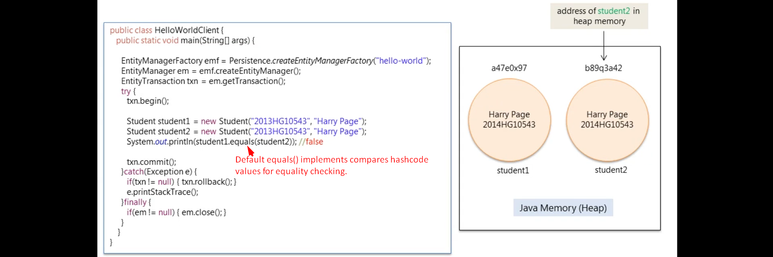
2. 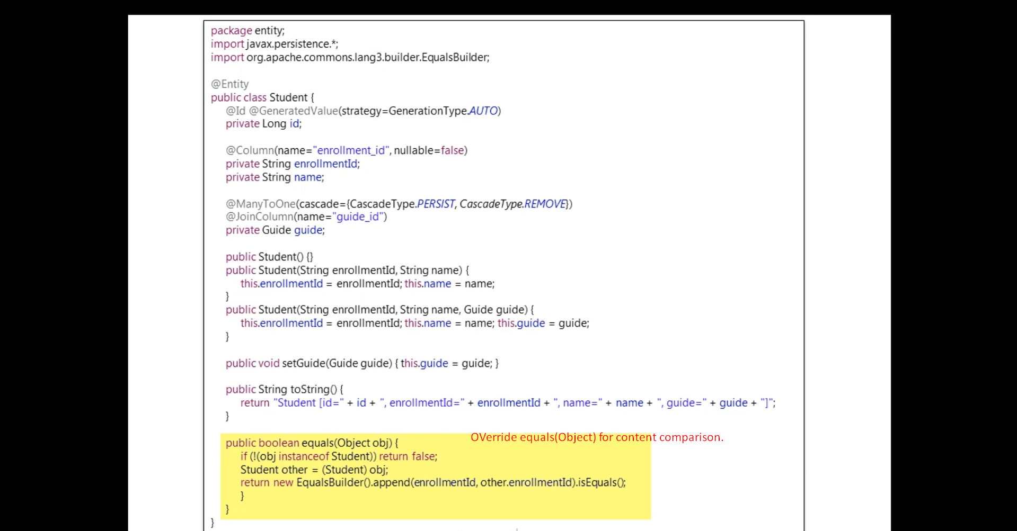
3. NOTE: Also override the hashCode() method when overriding equals(Object).
4. 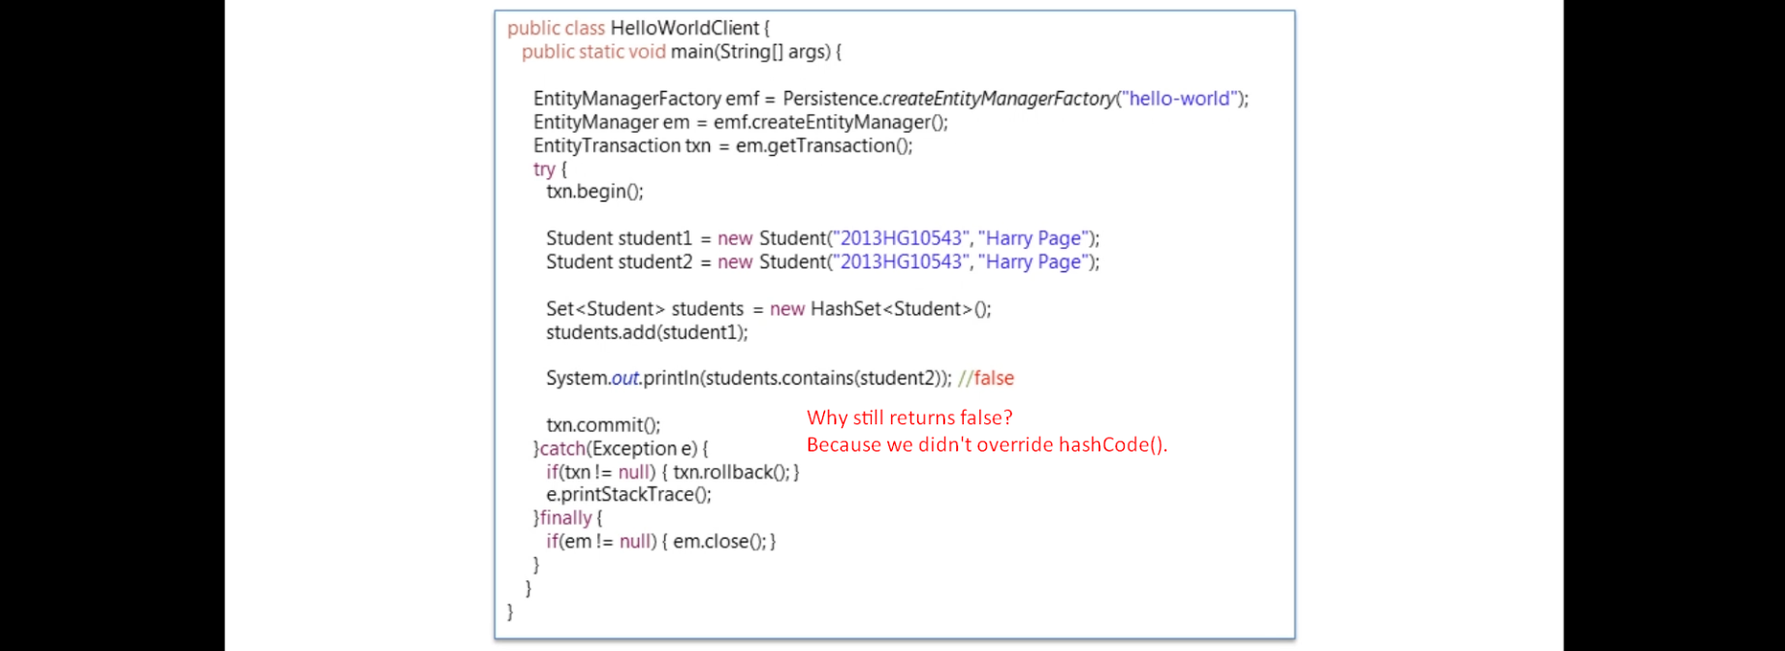
5. 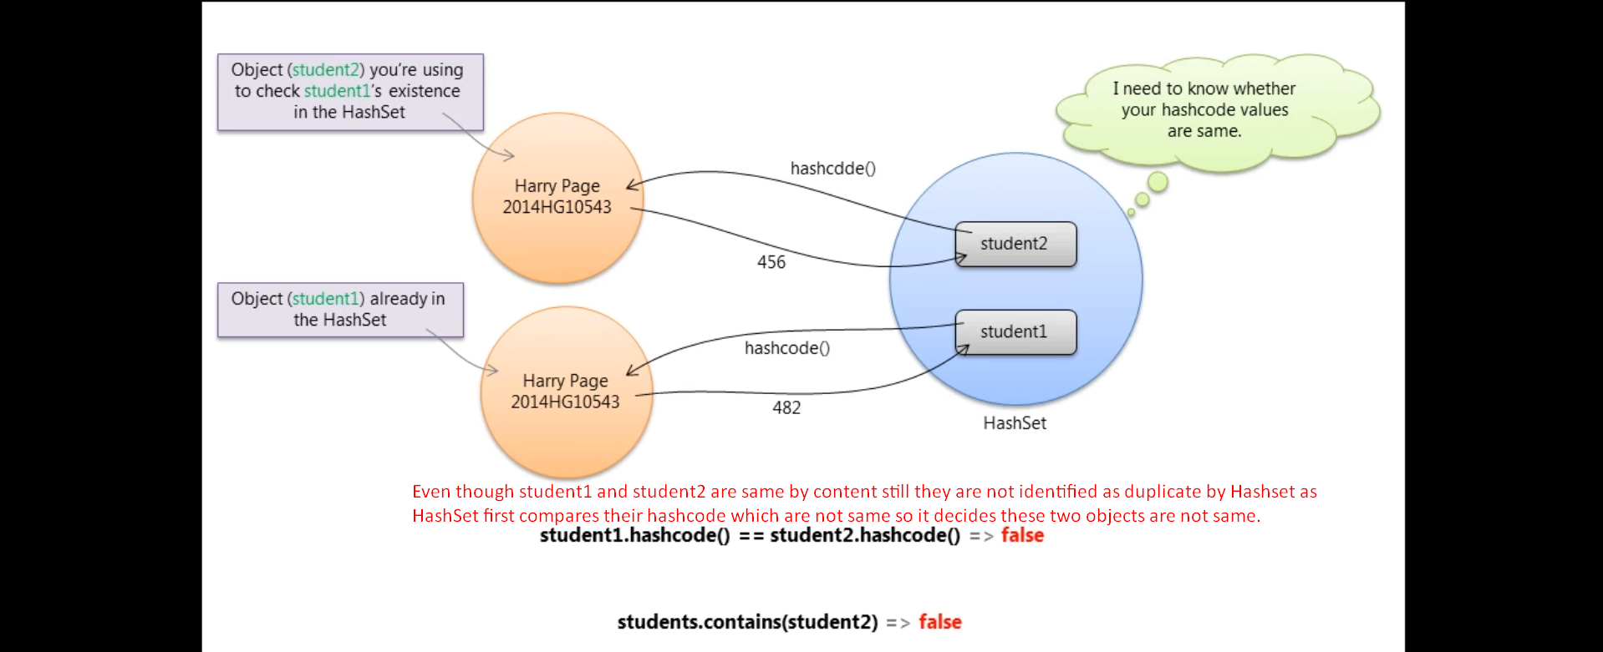
6. 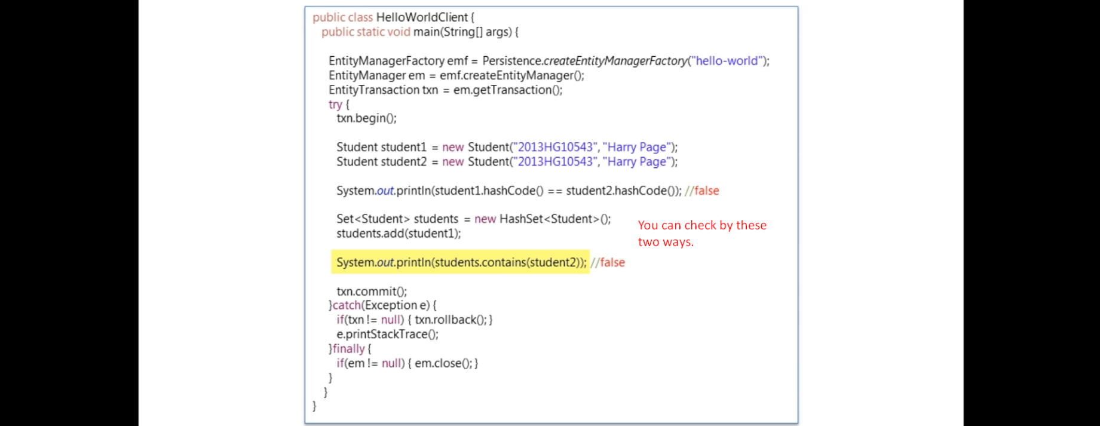
7. 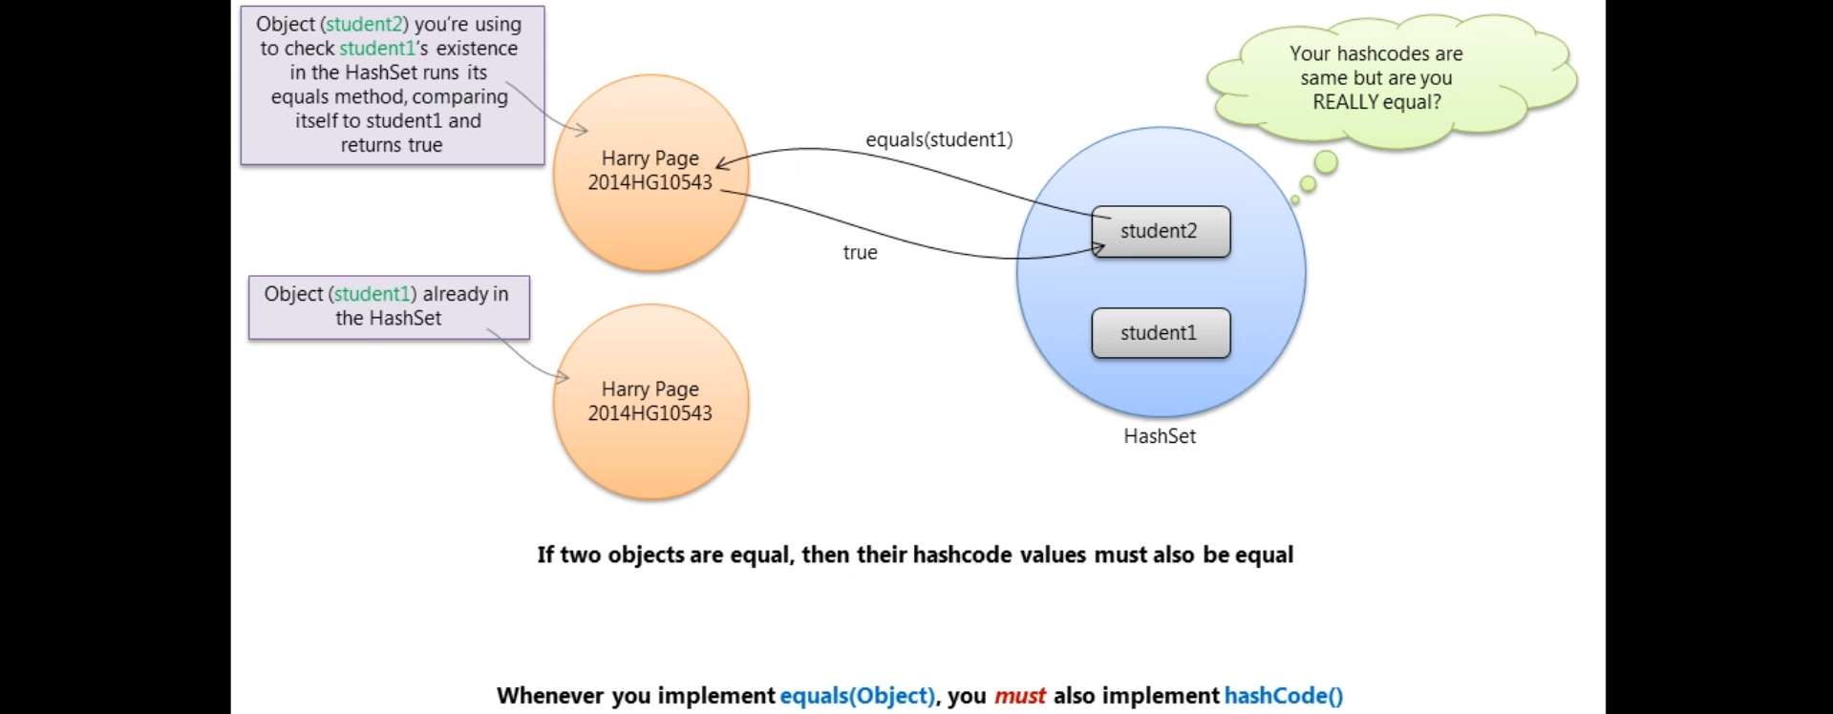
8. 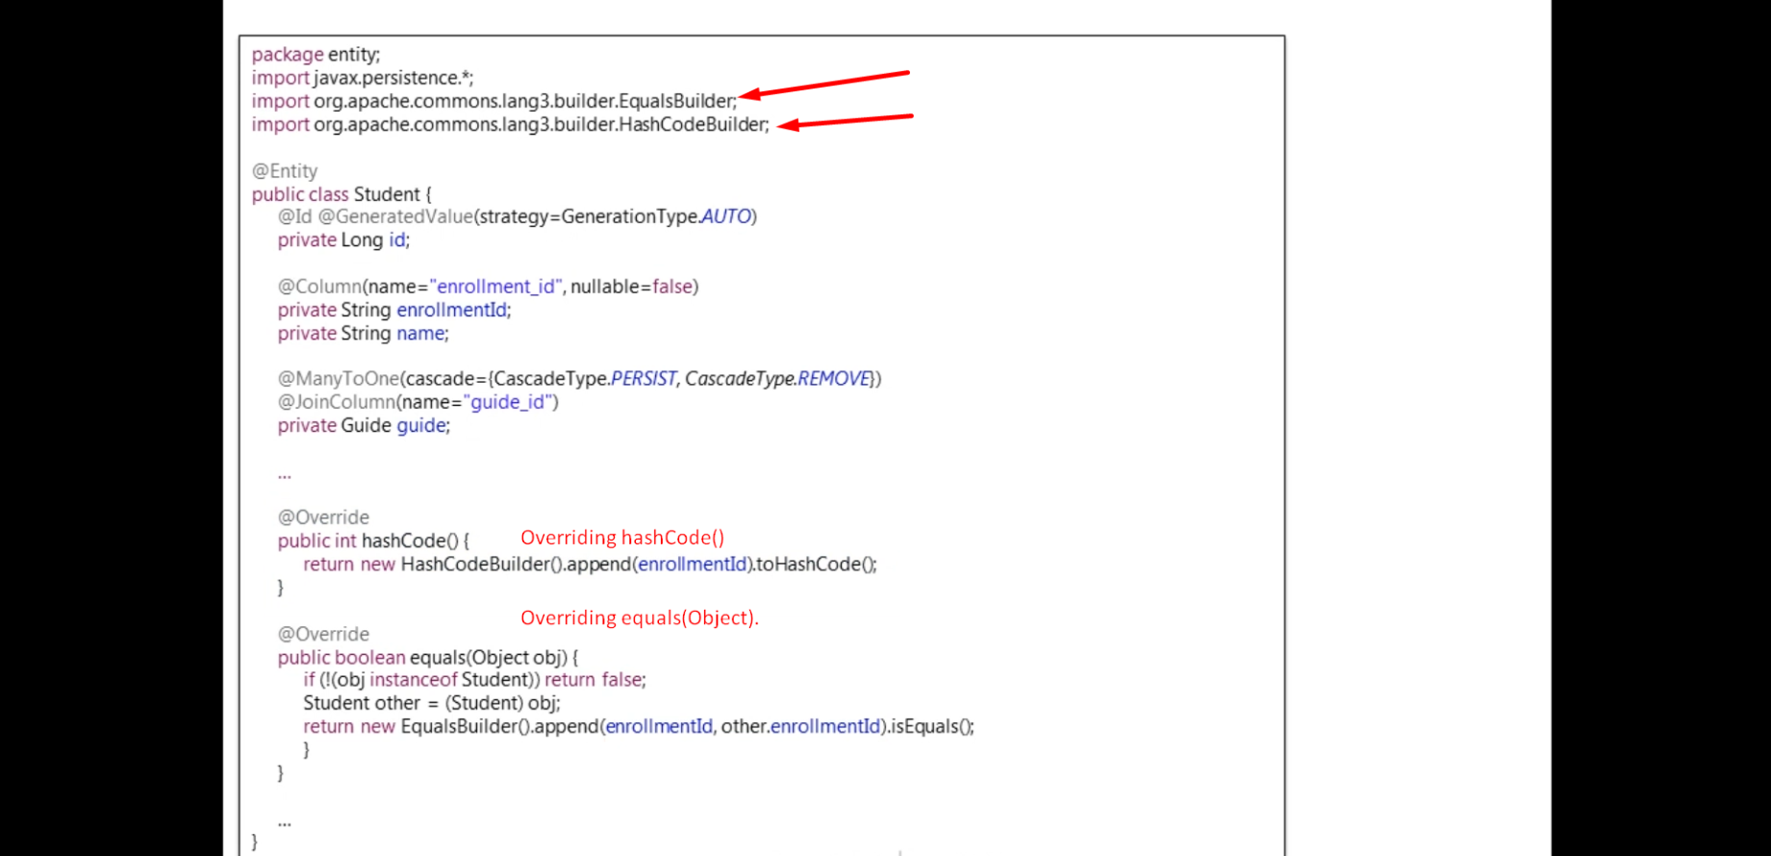
9. 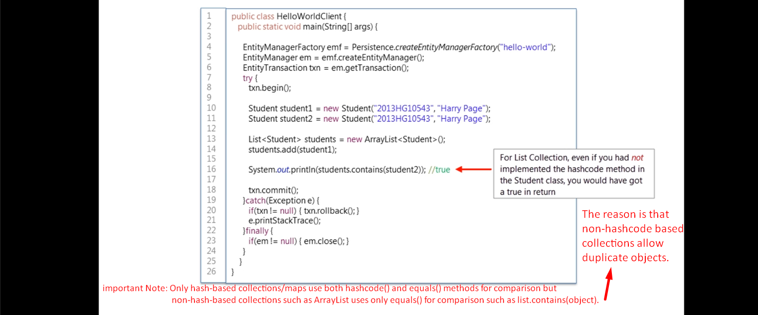Why hashcode() overriding is not important in case of List (List.contains(Object) doesn’t call hashcode() whereas Set.Contains(Object), Map.contains(Object) call hashcode() before calling equals())  
   Answer: As we know List allows duplicate objects so we don’t care about hashcode() and equals() method to override. Now list has a lot of duplicate objects. What if for each object it is calling hashcode() which will not help to identify if a particular object is contained inside the list or not.
10. Everything we covered so far is standard Java.
11. But things get changed when talking about JPA.
12. 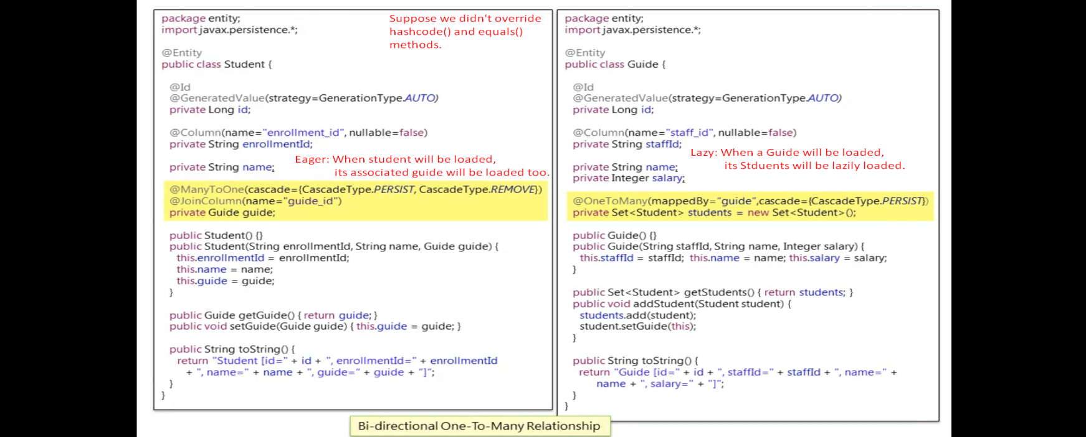
13. 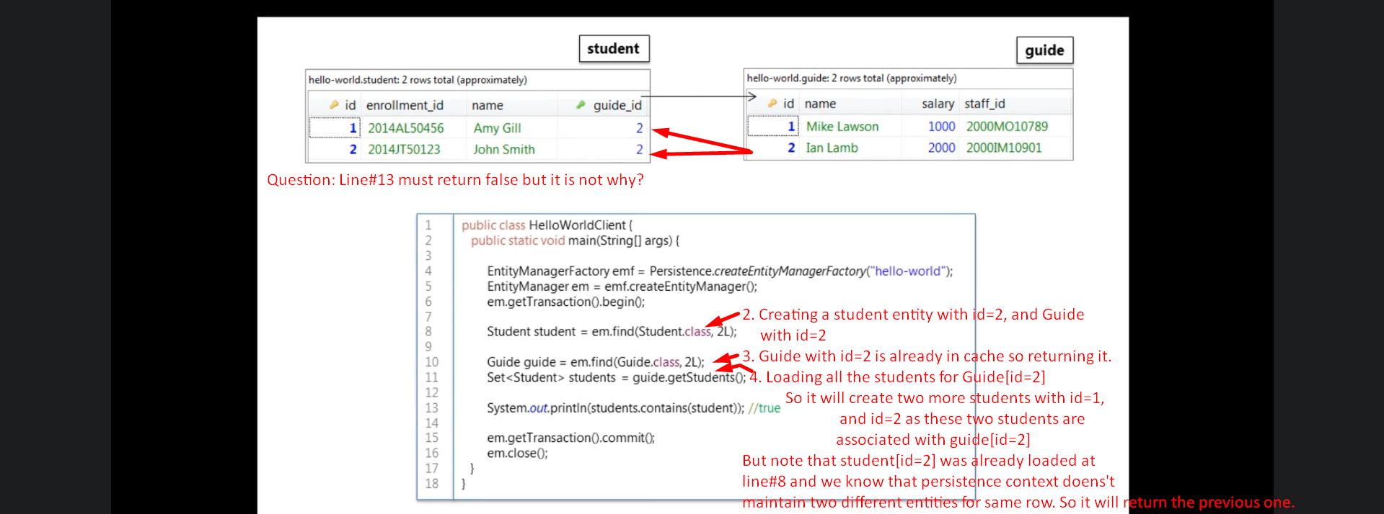Let’s understand the above with diagram.
14. 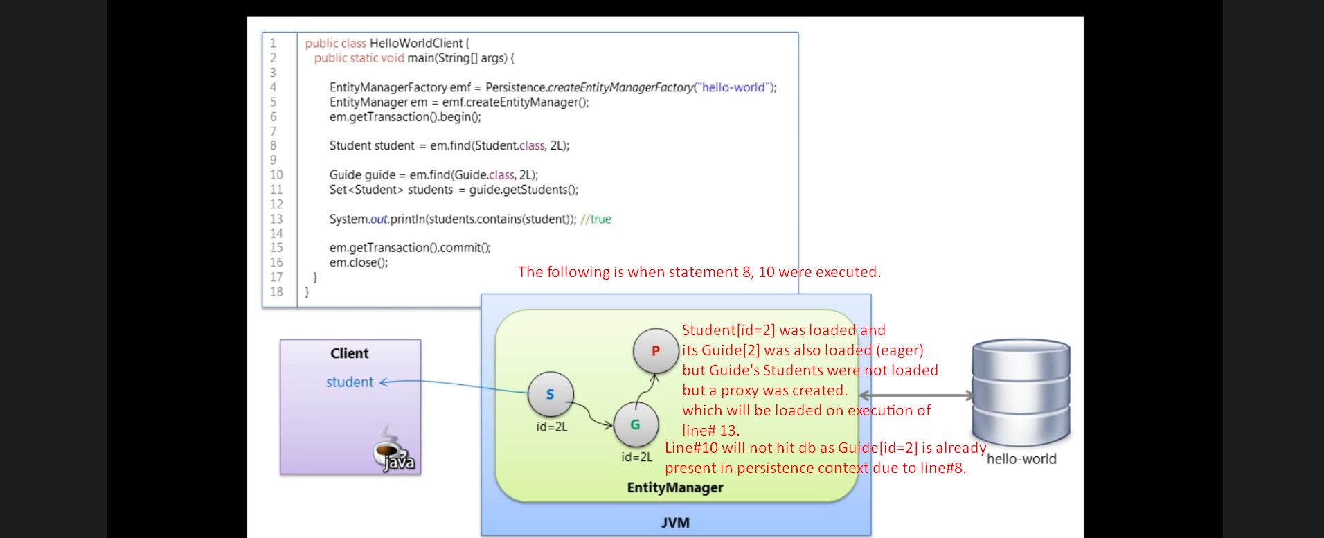  
    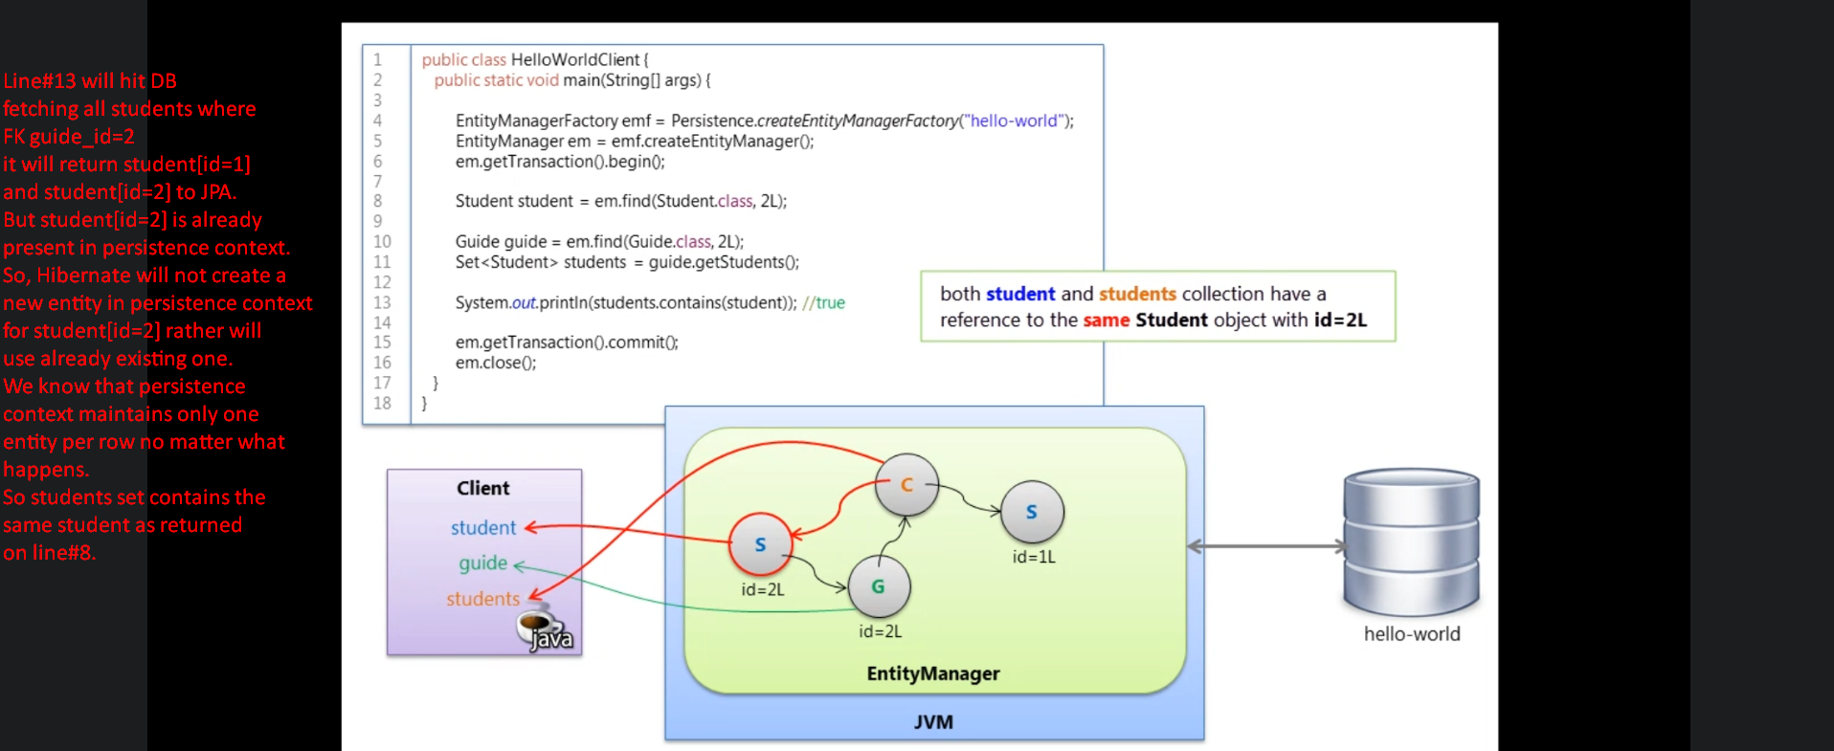
15. 